Process of Science

How Is Cardiovascular Fitness Measured?

Questions
1. What does a blood pressure measurement of 110/70 mean? Explain each number and its relationship to the heart functioning.

When the heart pumps blood it causes pressure on the blood vessels. This wave creates a peak amount of pressure, called the systolic pressure. Later the vessel will relax to a lower valley, called the diastolic pressure.

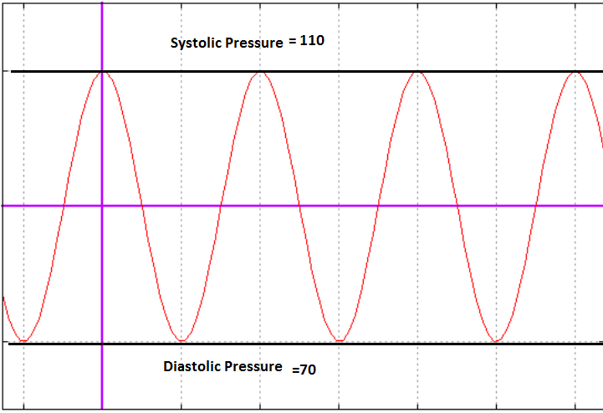

2. What is your resting heart rate?

52 beats per minute.

3. Which of the following resting pulse and resting blood pressure results would be typical of a well-conditioned athlete? 72 and 150/90; 48 and 110/80; 66 and 120/95; 84 and 110/75. Explain why?

The combination of 48 and 110/80 would be the well-conditioned athlete. This is because the body does not need to work as hard to send a sufficient amount of oxygen to the maintain homeostasis.

If the person was fat and out of shape the pressure on the vessels would be high such as the example of 150/90; which is likely a person with hypertension.

